CL2006 - Operating Systems Spring 2024

**LAB # 5 Revision of Labs 1 to 4 (Common)**

**Please note that all labs’ topics including pre-lab, in-lab and post-lab exercises are part of the theory and lab syllabus. These topics will be part of your Midterms and Final Exams of lab and theory.**

## Objectives:

Revision of Labs 1 to 4.

**Lab # 1:**

**Lab # 2:**

* Revised make file tutorial step by step in the lab (30 minutes)
* Explain Linux image compilation from source (10 minutes).

**Lab # 3:**

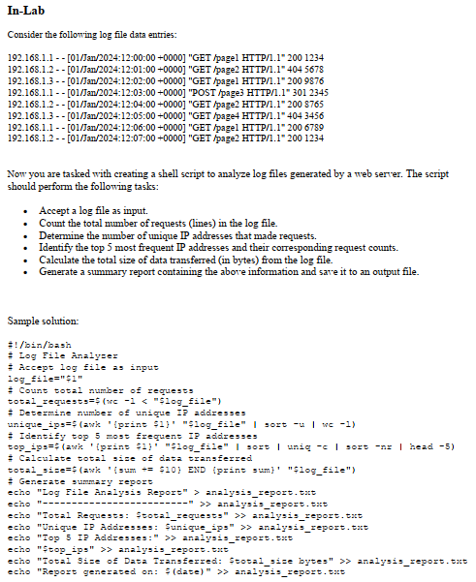

**Lab # 4:**

